Business Requirements Document (BRD)

Marriage Registration Module — Hindu Marriage (Kaveri 3.0)
Field | Value
Document ID | BRD-K3-MRG-HMA-001
Version | 0.2
Status | Draft / In review
Module | Marriage Registration
Legal basis (primary) | The Hindu Marriage Act, 1955 (Central Act 25 of 1955)
State rules (primary) | Registration of Hindu Marriage (Karnataka) Rules, 1966
Related inputs | Marriage/Hindu Marriage Act, 1955.pdf, Marriage/hindu marriage forms.pdf, Marriage/REGISTRATIONOFHINDUMARRIAGE_KARNATAKARULES_1966.docx, Marriage/RD48MNMU2023-Notification-marriage.pdf (confirm applicability)
Author (BA) | Nandha Kumar
Product Owner | Prashanth
Domain expert / SRO reviewer
Target audience | PO, BA, Domain Expert, Solution Architect, Dev, QA, Content
Last updated | 2026-08-24

Document control
Version | Date | Author | Summary of change | Approver
0.1 | [Date] | Nandha Kumar | Initial template / discovery draft | Prashanth
0.2 | 2026-08-24 | Nandha Kumar | Re-aligned To-Be process to updated Hindu Marriage Online & Offline diagrams — channel before prerequisite+declaration (combined), Online e-KYC on Bride details, offline SR allocates to DEO; replaced process figures; refreshed §7.2–7.4, status model, FRs, UI, stories | Prashanth

Related documents:
ID | Title | Link
BRD-K3-MRG-HMA-001 | This document
PROC-K3-MRG-HMA-TOBE-001 | To-Be process flows | Process Diagrams/hindu marriage Online.png, Process Diagrams/hindu marriage Offline.png, Process Diagrams/Special Marriage (Intended Marriage Notice) 1.png, Process Diagrams/Special Marriage Other Forms.png
RTM-K3-MRG-HMA-001 | Requirements traceability matrix | [TBD]
DEC-K3-MRG-001 | Decision log | [TBD]
BRD-K3-MRG-SMA-001 | Special Marriage (separate BRD) | Out of scope for this template unless merged

Contents
1. Executive summary
2. Scope
2.1 In scope (Hindu Marriage — Phase [1])
2.2 Out of scope (unless PO promotes)
2.3 Assumptions
2.4 Constraints
3. Legal and regulatory reference
3.1 Primary legislation — Hindu Marriage Act, 1955 (selected sections for registration)
3.2 Karnataka Rules, 1966 (operational rules)
3.3 Statutory forms mapping
4. Stakeholders and actors
5. Definitions and glossary
6. Current state (As-Is)
6.1 As-Is pain points
7. Future state (To-Be)
7.1 Channel model
7.2 Common intake steps (both channels)
7.3 To-Be process - Hindu Marriage Online
7.4 To-Be process - Hindu Marriage Offline
7.5 To-Be Process - Special Marriage (Intended Marriage Notice)
7.6 To-Be Process – Special Marriage Other Forms
8. Functional requirements
8.1 Eligibility and module entry
8.2 Jurisdiction and office routing
8.3 Data capture — marriage details (Form I items 1–2)
8.4 Data capture — bridegroom (Form I &3)
8.5 Data capture — bride (Form I &4)
8.6 Data capture — witnesses (Form I &5–7, Rule 4(3))
8.7 Form IA — application and declarations
8.8 Documents and memorandum
8.9 Fees and payments
8.10 SRO scrutiny and registration
8.11 Post-registration services
8.12 Notifications
8.13 Reports and MIS
8.14 Channel selection and prerequisite acknowledgement
8.15 Online channel — office selection, Form 1A submission and eSign
8.16 Offline channel — printout, physical signature and DEO upload
8.17 SR verification (channel-aware)
8.18 Digital signature and certificate issuance
8.19 Workflow, notifications and audit for the new steps
9. Business rules
10. User stories / use cases (template)
10.1 Use case format
10.2 Starter backlog (MVP)
10.3 Channel-specific use cases to be detailed
11. User interface (high-level)
12. Integrations
13. Non-functional requirements
13.1 Availability
13.2 Performance
13.3 Scalability
13.4 Security
13.5 Privacy
13.6 Audit
13.7 Disaster recovery (DR)
13.8 Operations
13.9 Capacity
13.10 Compliance
13.11 NFR open points (decision log)
14. Data requirements
14.1 Core entities (logical)
14.2 Retention
14.3 Migration (high level)
15. Requirements traceability matrix (RTM) — template
16. Open questions and decision log
16.1 Open questions
16.2 Decisions
17. Acceptance and sign-off
Appendix A — Form I field matrix (duplicate for bridegroom &3, bride &4, witnesses &5–7)
Appendix B — Form IA declaration text (verify against latest gazette)
Appendix C — Form II / II-A data elements
Appendix D — References

Executive summary
This document presents a comprehensive assessment of the existing Hindu Marriage Registration process, covering both online and offline service channels. It identifies key operational, procedural, and user experience challenges currently impacting applicants, registration authorities, and supporting stakeholders.
Based on the analysis of the current state, the document proposes an enhanced future-state workflow aimed at improving accessibility, efficiency, transparency, and service delivery. In addition, it defines the functional and non-functional requirements necessary to support the envisioned process, outlines the data requirements required for effective implementation and management, and provides a detailed traceability matrix to ensure alignment between business objectives, requirements, and solution deliverables.
The proposed approach is intended to streamline marriage registration services, reduce manual effort, enhance compliance, and establish a scalable foundation for future digital transformation initiatives.

2. Scope

2.1 In scope (Hindu Marriage — Phase [1])
- Registration of already solemnized Hindu marriages under Section 8, HMA 1955.
- Statutory artefacts: Form I (Memorandum), Form IA (Application), Form II (Registrar endorsement), Form II-A (Certificate), Form III (monthly duplicate bundle certificate to Registrar-General) — system support as applicable.
- Jurisdiction: marriage place or ordinary residence of bride/bridegroom (per Karnataka Rule 4, as amended).
- Parties: bride, bridegroom, three witnesses (memorandum signed by three witnesses per Rule 4(3)).
- Citizen portal + SRO desk workflows: apply, pay fee, scrutiny, approve/reject, register, issue certificate, reprint/corrected extract (per rules).
- Two processing channels per approved process diagrams (§7.3–7.4): Hindu Marriage Online (channel selection → prerequisite & declaration → e-KYC bride capture → office/summary → Form 1A → eSign → single SR verification → online payment → SR DSC → certificate) and Hindu Marriage Offline (channel selection → prerequisite & declaration → data capture → SR Stage 1 → payment & appointment → printout Form I / II / 1A → SR allocates to DEO → DEO signature check & upload → SR Stage 2 → SR DSC → certificate).
- Integrations: [payment, Aadhaar/eKYC, DigiLocker, SMS, e-Mai, Kutumba portal, Civil Registration System, Labor Department].
- Bilingual UI: English + Kannada (labels, certificate text where mandated).
- Audit trail, role-based access, MIS/reporting for department.

2.2 Out of scope (unless PO promotes)
- Special Marriage Act 1954 (separate BRD).
- Parsi / Christian / Muslim marriage Acts.
- Matrimonial petitions (divorce, judicial separation, restitution) under HMA Part III onward.
- Priest-led solemnization scheduling (unless department requires).
- Legacy data migration detail (flag for Data Migration specialist; high-level requirements only here).

2.3 Assumptions
ID | Assumption | Owner to validate
A-01 | Sub-Registrars under Indian Registration Act, 1908 act as Registrars of Hindu Marriages for their jurisdiction (Karnataka notification) | Domain Expert
A-02 | Registration is optional under Section 8 but mandatory for process once parties choose to register via Kaveri | Legal / DE
A-03 | Joint photograph on memorandum is required as per Form I layout | DE / SRO
A-04 | Fee schedule follows Karnataka Rules Schedule + RD48 notification where applicable | Treasury / DE
A-05 | [TBD]

2.4 Constraints
- GIGW / MeitY guidelines, accessibility (WCAG 2.x), Karnataka e-Gov hosting/security norms.
- Aadhaar / eKYC usage only as approved by department and UIDAI compliance.
- No alteration of statutory form wording on generated outputs without legal approval.

3. Legal and regulatory reference

3.1 Primary legislation — Hindu Marriage Act, 1955 (selected sections for registration)
Section | Topic | BRD relevance
2 | Application of Act | Who may register as Hindu marriage (Hindu, Buddhist, Jaina, Sikh; exclusions e.g. Scheduled Tribe unless notified)
3 | Definitions | Custom, sapinda, degrees of prohibited relationship — validation rules
5 | Conditions for marriage | Eligibility declarations in Form IA; system validations where automatable
7 | Ceremonies | Declaration that marriage solemnized per customary rites
8 | Registration | Core registration authority; state rules under sub-section (1)
11–12 | Void / voidable | [Optional] flags for SRO manual review; not full court workflow
17–18 | Penalties | Inform citizen/SRO messaging; no bigamy if spouse living (Sec. 5(i))

Section 5 — conditions (for business rules table):
Condition | Statutory requirement | System handling (To-Be)
5(i) | Neither party has a spouse living at time of marriage | Mandatory declaration + [TBD: document / cross-check]
5(ii) | Valid consent; no unsoundness of mind etc. | Declaration; SRO may reject
5(iii) | Bridegroom ≥ 21 years; Bride ≥ 18 years at marriage | DOB/age validation vs marriage date
5(iv) | Not within degrees of prohibited relationship (unless custom) | [TBD: relationship capture + rule engine / manual]
5(v) | Not sapindas of each other (unless custom) | [TBD: as above]

Section 7: Marriage solemnized per customary rites and ceremonies of either party — capture ceremony type/description; SRO verification.
Section 8: Parties may furnish particulars; state may make rules for registration and evidence — drives forms, register, certificate.

3.2 Karnataka Rules, 1966 (operational rules)
Rule | Requirement | System feature
3 | Appointment of Registrars (Sub-Registrars) | Office/jurisdiction master; route application to correct SRO
4(1) | Form I memorandum in duplicate; deliver in person or registered post; jurisdiction: place of marriage or ordinary residence of bride/bridegroom | Dual copy tracking; office selection logic
4(2) | Memorandum accompanied by Form IA application | Linked application record
4(3) | Memorandum and duplicate signed by three witnesses | Three witness records + e-sign / signature capture [TBD]
4(4) | Registrar endorsement Form II on reverse; paste memorandum in serial register | Register serial no., page, volume; endorsement generation
4(5) | Issue Form II-A certificate on completion | Certificate PDF + QR/seal [TBD]
4 (duplicates) | Monthly Form III bundle to Registrar-General | Batch job / export [TBD]
4 (scrutiny) | Scrutinise memorandum + IA; refuse incomplete; written order to parties | Rejection workflow with reason codes
8 | Certified extracts; fees per Schedule | Fee master; receipt Form VI
Indices | Form IV, Form V | Reporting / search indexes

3.3 Statutory forms mapping
Form | Rule ref | Purpose | Generated by
Form I | Rule 4 | Memorandum of marriage (duplicate) | System from captured data + joint photo
Form IA | Rule 4(2) | Application to enter particulars in register | System + party signatures
Form II | Rule 4(4) | Endorsement on reverse of memorandum | SRO on registration
Form II-A | Rule 4(5) | Certificate of registration | System on approval
Form III | Rule 4 (duplicates clause) | Certificate on monthly duplicate bundle | Back-office batch
Form VI | Rule on fees | Fee receipt | Payment integration

4. Stakeholders and actors
Actor | Description | Primary goals | Channel involvement
Citizen (applicant) | Bride and/or bridegroom | Submit accurate application, pay fee, receive certificate | Online + Offline (portal login is common to both)
Bride / Bridegroom | Parties to marriage | Sign declarations, provide documents | Online: eSign; Offline: physical signature on printed Form I / II / 1A
Witness (×3) | Present at solemnization | Identity, address, signature on memorandum | Online: eSign / e-KYC [TBD]; Offline: physical signature
Marriage Registrar / Sub-Registrar (SR) | Statutory registrar | Verification, register, digital signature, refuse with order | Online: single verification; Offline: two verification stages
Data Entry Operator (DEO) | SRO-office operator handling physically signed forms | Check signatures on printed Form I / II / 1A and upload to portal | Offline only
Appointment / front-office desk | Slot management at SRO | Schedule and manage citizen visit | Offline only
IGSR / senior office | Oversight | Monitoring, escalations | Both
Treasury / payment gateway | Fee collection | Reconciliation | Both (payment triggered after first SR approval)
eSign / DSC service provider | Digital signing | Citizen eSign (online), SR digital signature (both) | Both
Registrar-General | State-level register | Receive Form III duplicates | Both (batch/export)
Domain Expert | Validation | Sign-off on rules and forms | Review workshops
CSG / Kaveri 2.0 support | Legacy reference | As-is behaviour | KT sessions

5. Definitions and glossary
Term | Definition | Source
Memorandum | Form I particulars of marriage | Karnataka Rules
Registrar | Registrar of Hindu Marriages (Sub-Registrar) | Rules + notification
Register | Paste-book Hindu Marriage Register | Rule 4(4)
Solemnization | Performance of customary rites (Section 7) | HMA 1955
Ordinary residence | [Define operational rule for jurisdiction] | DE / Rule 4
Sapinda / prohibited relationship | As Section 3 | HMA 1955
Prerequisite page | Combined mandatory read-and-continue screen (prerequisite for marriage + declaration) shown after channel selection and before application data entry | Updated process diagrams (both channels)
Hindu Marriage Online | Channel where citizen selects Online first, completes combined prerequisite+declaration, captures details with e-KYC on Bride, selects office, submits Form 1A with eSign; no physical form submission | Process Diagrams/hindu marriage Online.png
Hindu Marriage Offline | Channel where citizen selects Offline first, completes combined prerequisite+declaration, captures details, undergoes SR Stage 1, pays and books appointment, prints Form I/II/1A, SR allocates to DEO for signature check and upload, then SR Stage 2 and DSC | Process Diagrams/hindu marriage Offline.png
Special Marriage (Intended Marriage Notice) | Channel where the citizen can perform Intended marriage and have the marriage solemnized in the register office | Process Diagrams/Special Marriage (Intended Marriage Notice) 1.png
Special Marriage Other Forms | Channel where Non-Hindus register their marriage | Process Diagrams/Special Marriage Other Forms.png
eSign | Electronic signature applied by citizen on Form 1A / declarations in the Online channel | Process diagram; legal validity per OQ-002
SR digital signature (DSC) | Digital signature applied by Sub-Registrar before certificate issuance (both channels) | Process diagram
SR Verification | Sub-Registrar scrutiny decision (Approve / Reject). Offline has two occurrences: pre-payment data verification and post-upload signed-form verification | Process diagram
Data Entry Operator (DEO) | SRO-office role that checks signatures on the printed forms and uploads them to the portal (Offline only) | Process diagram (Offline swimlane)
Appointment | Scheduled SRO visit slot booked by the citizen together with payment in the Offline channel | Process diagram (Offline)
Channel | Online or Offline processing route chosen by the citizen after Marriage Registration service selection and before the prerequisite+declaration screen | Process diagram

6. Current state

6.1 As-Is pain points
Sr.No | Pain Point | Description | Source
1 | Not mobile-friendly | The application is not usable on mobile browsers, limiting citizen access on phones and tablets. | Discussion
2 | Incorrect address on certificate | Sub-district is incorrectly included in the address shown on the marriage certificate. | Discussion
3 | Complex area/village selection | Selecting area or village is cumbersome and difficult for applicants to complete accurately. | Discussion
4 | Restrictive document upload rules | Uploaded image file size is too small, and mandatory pixel/dimension checks block valid uploads. | Discussion
5 | Missing Save action for Witness 3 | The 'Save Witness 3' action is missing from the workflow. | Discussion
6 | Edit does not return to correct step | Using Edit from an in-progress marriage application does not open the latest or relevant step (e.g., Marriage Details screen). | Discussion
7 | Documents not visible during scrutiny | Supporting documents uploaded with the application are not reliably visible to marriage registrar during application scrutiny. | Discussion
8 | No edit flexibility before payment | Applicants cannot freely go back to earlier steps and edit data. | Discussion
9 | No processing priority order | Applications are not handled in first-in, first-out (FIFO) order, affecting fairness and turnaround time. | Discussion
10 | Password-protected uploads not handled | The system accepts or fails unclearly on password-protected documents instead of blocking them with a clear message. | Discussion
11 | Limited notification channels | Notifications are not sent through both SMS and email as expected by the citizens and officers. | Discussion
12 | No operational dashboard visibility | There is no dashboard showing daily registration count, pending applications, or processed applications. | Discussion
13 | Wrong DEO allocation and no reassignment | Applications are frequently allocated to the wrong DEO by mistake. Officers cannot return, reassign, clear, or remove applications from DEO login without ServiceDesk intervention (~66 tickets; 8 in last 3 months — still active). | Service Desk
14 | Notice workflow state errors | After notice period completion, the system still shows Generate Notice or Print Notice instead of advancing. Notice steps reappear after second payment. | Service Desk
15 | Blank challan / verify-challan loop | Citizen payment fails because the portal shows Verify Challan with a blank challan, forcing repeated payment attempts and helpdesk tickets (~38 tickets). | Service Desk
16 | Stuck on summary page — cannot go to next step | Users cannot proceed past the summary/review page to the next workflow step, leaving applications blocked mid-process (~41 tickets). | Service Desk
17 | DOB and party details not reflecting | Date of birth and related bride/bridegroom details entered in the application do not reflect on subsequent screens or the certificate (~21 tickets). | Service Desk
18 | Place of marriage missing in summary/report | Place of Marriage captured during data entry does not appear in the review summary page or summary report (~12 tickets; also listed in curated issues list). | Service Desk
19 | Cross-reference to registered marriage missing | There is no usable provision to add cross-references to a registered marriage. Multiple recent tickets (May–Jun 2026) request this repeatedly. | Service Desk
20 | Signatures missing on digitally signed certificate | After digital signing, bride, bridegroom, and witness signatures do not appear on the generated certificate | Service Desk
21 | Notice number and notice date not displaying | Notice number and notice date do not show on the relevant screens after notice generation, affecting verification and further processing (repeated in last 3 months). | Service Desk

7. Future state (To-Be)
Source of truth for this section: approved process diagrams
Process Diagrams/hindu marriage Online.png
Process Diagrams/hindu marriage Offline.png
Process Diagrams/Special Marriage (Intended Marriage Notice) 1.png
Process Diagrams/Special Marriage Other Forms.png

7.1 Channel model
The Marriage Registration system supports multiple service delivery channels based on the applicable marriage type and statutory requirements. While all services are initiated through the online portal, the level of online processing and physical interaction varies by service.
Service Type | Online Activities | Office Activities | Mode
Hindu Marriage Online | Registration, e-KYC (Bride), eSign, Payment (post-approval), Tracking | Verification, DSC | Online
Hindu Marriage Offline | Registration, Payment, Appointment Booking, Printout | SR Stage 1, SR→DEO allocation, Form upload, SR Stage 2, DSC | Offline
Special Marriage Intended Notice | Application, Document Upload, Payments | Notice Publication, Objection Handling, Solemnisation | Hybrid
Special Marriage Other Forms | Application, Uploads, Payments | Verification, Hearings/Approvals (if applicable) | Hybrid

7.2 Common intake steps (both channels)
Identical in both diagrams (Citizens and System lanes):
- START — citizen initiates the service.
- LogOn to Portal — authenticated citizen session.
- Start a new Application.
- Select Marriage Registration service.
- Select channel: Hindu Marriage Online / Hindu Marriage Offline (or Special Marriage Intended Marriage Notice / Special Marriage Other Forms). Channel is chosen before prerequisites (per updated diagrams).
- Read and continue with Prerequisite for marriage and complete declaration — single combined acknowledgement screen (eligibility, documents, channel implications and statutory declarations).
- Enter / capture Marriage details, Bride details, Bridegroom details, Witness details — persisted to the application record. Online channel: e-KYC on Bride details (see §7.3). This step is the re-entry point for SR rejection loops that return to citizen data entry in both diagrams.

7.3 To-Be process — Hindu Marriage Online
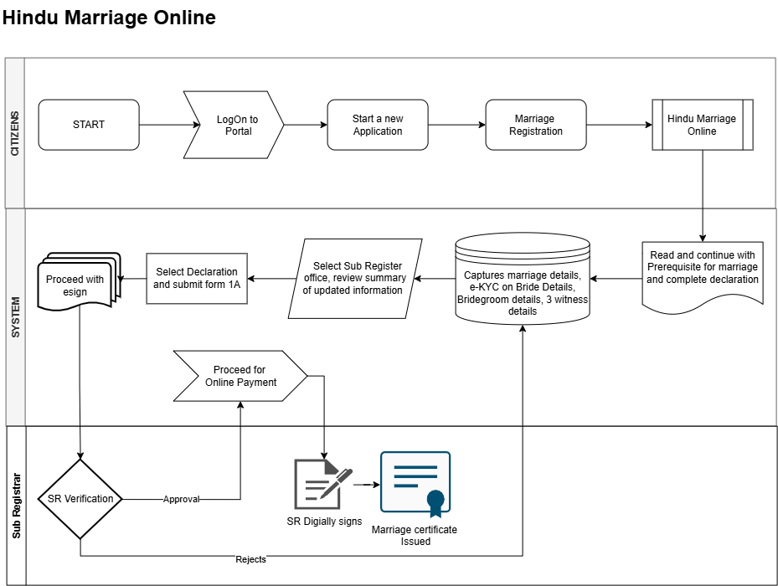
Figure: Hindu Marriage Online process
Flow (continuing from §7.2 step 7 — Online-specific steps):
# | Step | Lane | Notes
7 (Online nuance) | Capture marriage / e-KYC on Bride details / Bridegroom / 3 witness details | System / Citizen | Per Online diagram: e-KYC applied on Bride details during capture (Bridegroom e-KYC — see OQ-015)
8 | Select Sub-Registrar office and review summary of updated information | System / Citizen | Jurisdiction routing per Rule 4
9 | Select Declaration and submit Form 1A | System / Citizen | Form 1A generated for the selected office
10 | Proceed with eSign | System / Citizen | Citizen eSign on Form 1A and declarations
11 | SR Verification (decision) | Sub Registrar | Approve or Reject
11a | Reject → return to Enter Marriage / Bride / Bridegroom / Witness details | Sub Registrar → System | Citizen corrects and resubmits; refusal reason recorded
12 | Proceed for Online Payment | System / Citizen | Payment occurs only after SR approval
13 | SR Digitally signs | Sub Registrar | DSC applied
14 | Marriage certificate Issued | Sub Registrar / System | Form II-A available for download

Key characteristics: channel before combined prerequisite+declaration; e-KYC on Bride details during capture; office selection + summary; Form 1A + eSign; no printout, no appointment, no DEO; single SR verification; payment only after SR approval; fully digital signature chain.

7.4 To-Be process — Hindu Marriage Offline
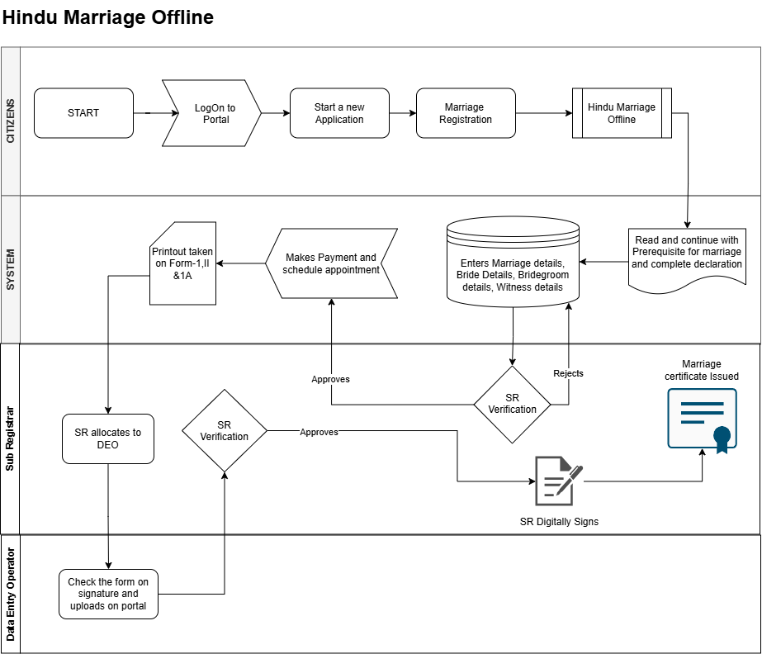
Figure: Hindu Marriage Offline process
Flow (continuing from §7.2 step 7 — Offline-specific steps):
# | Step | Lane | Notes
8 | SR Verification — Stage 1 (decision) on captured application data | Sub Registrar | Approve or Reject
8a | Reject → return to Enter Marriage / Bride / Bridegroom / Witness details | Sub Registrar → System | Citizen corrects and resubmits
9 | Makes Payment and schedule appointment | System / Citizen | Payment and slot booking in one step, after Stage 1 approval
10 | Printout taken on Form-1, II & 1A | System / Citizen | Citizen prints the statutory forms
11 | SR allocates to DEO | Sub Registrar | Explicit allocation step per updated Offline diagram before DEO upload
12 | Parties and witnesses sign physically; citizen attends the SRO on the appointment date | Citizen (offline activity) | Not a system step; precondition for DEO upload
13 | Check the form on signature and uploads on portal | Data Entry Operator | DEO verifies signatures are present/complete, scans and uploads
14 | SR Verification — Stage 2 (decision) on the uploaded signed forms | Sub Registrar | Approve or Reject
14a | Reject → return to DEO check / upload step | Sub Registrar → DEO | Re-check or re-upload; does not go back to citizen data entry
15 | SR Digitally Signs | Sub Registrar | DSC applied
16 | Marriage certificate Issued | Sub Registrar / System | Form II-A issued

Key characteristics: channel before combined prerequisite+declaration; SR Verification Stage 1 on captured data before payment; payment + appointment bundled; printout of Form I, II & 1A; SR allocates to DEO; DEO signature check and upload; SR Verification Stage 2 on uploaded signed forms (reject returns to DEO); SR DSC then certificate.

7.5 To-Be process - Special Marriage (Intended Marriage Notice)
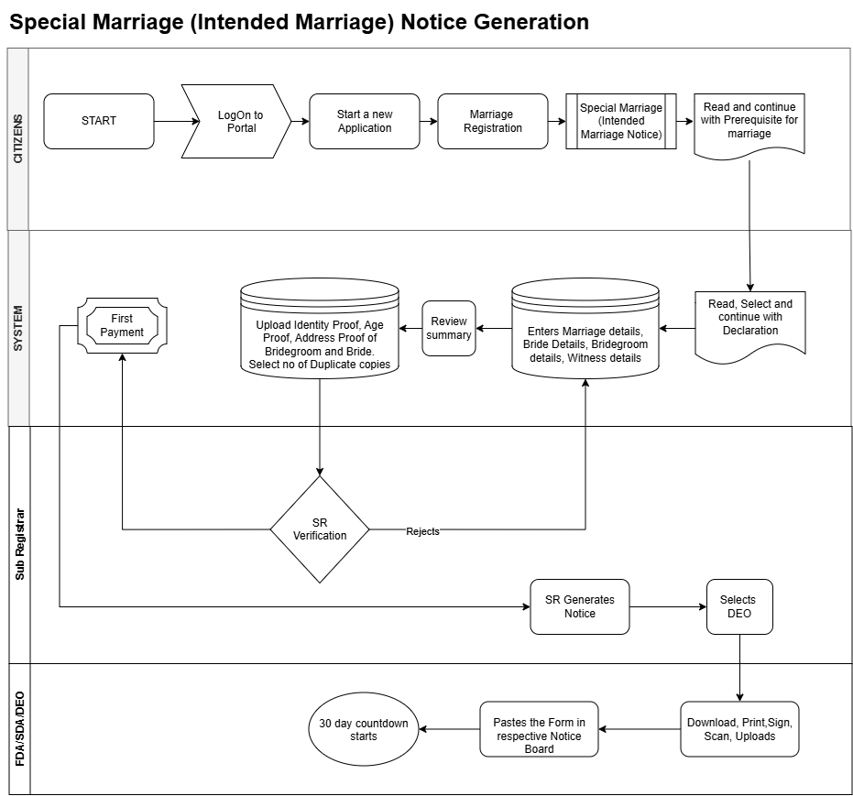
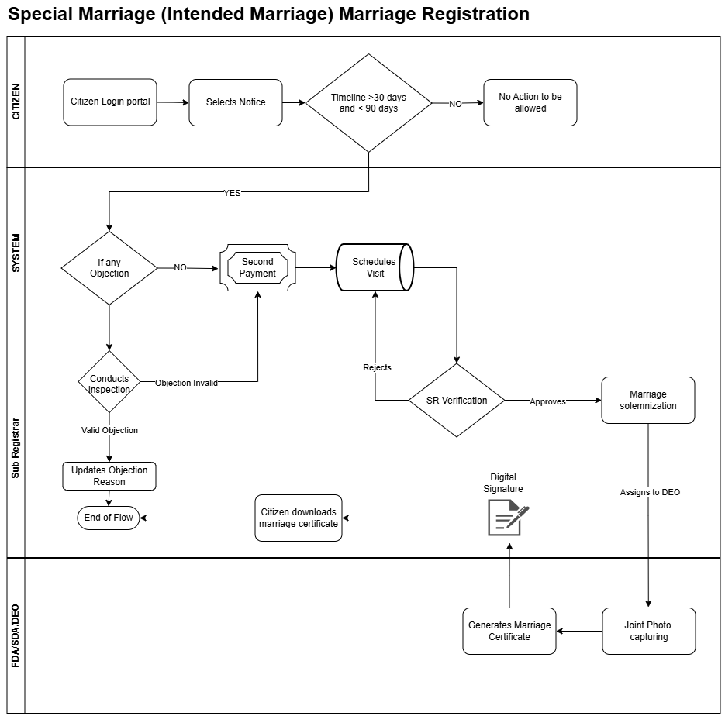
Figure: Special marriage (Intended Marriage Notice)
Flow (continuing from &7.2 step 8):
# | Step | Lane | Notes
9 | Review Summary | System | Citizens review the entered application details before submission.
10 | Upload Identity Proof, Age Proof, Address Proof and Bride/Bridegroom Photographs | System / Citizen | Mandatory documents required for notice generation.
11 | First Payment | System / Citizen | Notice application fee is collected.
12 | SR Verification (decision) | Sub Registrar | Approve or reject.
12a | Reject → return to Enter Marriage / Bride / Bridegroom / Witness Details | Sub Registrar → System | Citizen updates information and resubmit the application.
13 | SR Generates Notice | Sub Registrar | Statutory Intended Marriage Notice is generated.
14 | Select DEO/FDA/SDA | Sub Registrar | Notice publication activity assigned to an authorized official.
15 | Download, Print, Sign, Scan and Upload Notice | FDA / SDA / DEO | Physical notice is processed and uploaded into the system.
16 | Paste Notice in Designated Notice Board | FDA / SDA / DEO | Compliance with statutory publication requirements.
17 | 30-Day Countdown Starts | System | Statutory objection period commences from notice publication date.
18 | Citizens select approved Notice | Citizen | Registration process initiated against the published notice.
19 | Validate Timeline (>30 Days and <90 Days) | System | Registration can proceed only within the statutory validity period.
19a | Validation Failed | System | No further action permitted on the notice.
20 | Check for Objections | System | Determines whether any objection has been recorded.
21 | Conduct Inspection | Sub Registrar | Triggered when an objection exists.
21a | Valid Objection | Sub Registrar | Objection reason recorded; process terminated.
21b | Objection Invalid | Sub Registrar | Registration process continues.
22 | Second Payment | System / Citizen | Marriage registration fees are collected.
23 | Schedule Visit | System / Citizen | Citizen schedules appointment for marriage registration.
24 | SR Verification (decision) | Sub Registrar | Final verification before solemnization.
24a | Reject → return to Schedule Visit | Sub Registrar → System | Citizen may be required to reschedule or provide additional information.
25 | Marriage Solemnization | Sub Registrar | Marriage is solemnized as per statutory requirements.
26 | Assign to DEO/FDA/SDA | Sub Registrar | Certificate generation activities initiated.
27 | Joint Photo Capture | FDA / SDA / DEO | Photo captured and linked to marriage record.
28 | Generate Marriage Certificate | FDA / SDA / DEO | Certificate prepared in the system.
29 | Digital Signature Applied | Sub Registrar | Certificate digitally signed using DSC.
30 | Citizen Downloads Marriage Certificate | Citizen / System | Final certificate made available through the portal.

7.7 Application status model (channel-aware)
Status | Description | Channel | Actor | Next states
Draft | Saved not submitted | Both | Citizen | Channel selected
Channel selected | Online or Offline chosen (before prerequisites) | Both | Citizen | Prerequisite & declaration completed
Prerequisite & declaration completed | Combined prerequisite + declaration acknowledged | Both | Citizen | Details captured
Details captured | Marriage / bride (Online: e-KYC) / bridegroom / witness details saved | Both | Citizen | Office selected (Online) / Pending SR verification Stage 1 (Offline)
Office selected & summary reviewed | SRO office chosen, summary confirmed | Online | Citizen | Form 1A submitted
Form 1A submitted | Declaration selected and Form 1A submitted | Online | Citizen | eSign pending
eSign pending | Awaiting citizen eSign | Online | Citizen | Pending SR verification
Pending SR verification | Awaiting SR scrutiny | Online / Offline (Stage 1) | SR | Approved for payment / Rejected — data
Rejected — data correction | Sent back to citizen data entry | Both | SR | Details captured
Approved for payment | SR approved; fee payable | Both | SR | Payment completed
Payment completed | Fee paid, receipt issued | Both | System | Pending SR digital signature (Online) / Appointment scheduled (Offline)
Appointment scheduled | SRO visit slot booked | Offline | Citizen | Forms printed
Forms printed | Form I, II & 1A printout taken | Offline | Citizen | Allocated to DEO
Allocated to DEO | SR has allocated the application to a DEO | Offline | SR | Awaiting signed-form upload
Awaiting signed-form upload | Physically signed forms pending at SRO | Offline | Citizen / DEO | Signed forms uploaded
Signed forms uploaded | DEO checked signatures and uploaded | Offline | DEO | Pending SR verification — Stage 2
Pending SR verification — Stage 2 | Awaiting SR scrutiny of signed forms | Offline | SR | Pending SR digital signature / Rejected — upload
Rejected — upload | Sent back to DEO for re-check / re-upload | Offline | SR | Signed forms uploaded
Pending SR digital signature | Awaiting DSC | Both | SR | Registered
Registered | Serial / page / volume assigned, Form II endorsed | Both | SR | Certificate issued
Certificate issued | Form II-A issued / downloadable | Both | System | Closed
Closed | No further action | Both | System | —

7.7 Process changes introduced by the new diagrams
# | Change vs earlier BRD draft | Impact
C-01 | Payment now occurs after SR approval, not before scrutiny | Reverses earlier "Paid → Under scrutiny" sequence; affects status model, fee reconciliation, and abandoned-application handling
C-02 | Explicit Online vs Offline channel fork after prerequisite page | New channel attribute on the application; channel-specific screens and SLAs
C-03 | Citizen eSign introduced (Online) | New eSign integration; legal validity to be confirmed (OQ-002)
C-04 | Two-stage SR verification (Offline) | Two distinct decision records, reasons and rejection targets
C-05 | New Data Entry Operator role and portal upload console | New role, RBAC entry, audit events, and training need
C-06 | Appointment scheduling bundled with payment (Offline) | Slot management, capacity, reschedule / no-show rules [TBD]
C-07 | Printout of Form I, II & 1A as a citizen step (Offline) | Print templates must be legally exact; Form II printed before SR endorsement — sequencing to be confirmed (OQ-006)
C-08 | Rejection loops return to specific re-entry points | Workflow engine must support targeted rework, not generic "resubmit"
C-09 | Channel selection now precedes the combined Prerequisite + Declaration screen (updated diagrams) | Status model, UI order, FR-HMA-140/141 and UC-HMA-010 reordered
C-10 | Online capture explicitly includes e-KYC on Bride details | Aadhaar/eKYC integration mandatory for Online Bride capture; OQ-015 for Bridegroom
C-11 | Offline: explicit 'SR allocates to DEO' step after printout, before DEO upload | New allocation status, SR workbench action, audit event

8. Functional requirements

8.1 Eligibility and module entry
Req ID | Requirement | Priority | Acceptance criteria
FR-HMA-001 | System shall allow registration only for marriages claimed to be solemnized under HMA 1955 (Section 2 applicability) | Must | [Given/When/Then]
FR-HMA-002 | System shall block or warn if marriage date is in future | Must
FR-HMA-003 | System shall enforce minimum age at date of marriage: bridegroom 21, bride 18 (Section 5(iii)) | Must
FR-HMA-004 | System shall capture marital status at time of marriage (unmarried / widower / widow / divorced) per Form I | Must

8.2 Jurisdiction and office routing
Req ID | Requirement | Priority | Acceptance criteria
FR-HMA-010 | Applicant shall select basis for jurisdiction: place of marriage or ordinary residence of bride/bridegroom (Rule 4) | Must
FR-HMA-011 | System shall route application to Sub-Registrar office matching selected jurisdiction | Must
FR-HMA-012 | If memorandum relates to marriage outside registrar jurisdiction, system shall support forward to correct registrar with intimation (Rule 4(2) second part / defect rule) | Should

8.3 Data capture — marriage details (Form I items 1–2)
Req ID | Requirement | Priority | Acceptance criteria
FR-HMA-020 | Capture date of marriage | Must
FR-HMA-021 | Capture place of marriage with sufficient particulars to locate (address, district, state) | Must
FR-HMA-022 | Capture description of ceremony / rites (Section 7) | Should

8.4 Data capture — bridegroom (Form I &3)
Field (statutory) | Mandatory | Validation / notes | Kaveri 3.0 field name
Full name | Y |  | [TBD]
Father's name | Y
Mother's name | Y
Age at marriage | Y | Cross-check DOB
Usual place of residence | Y | Jurisdiction helper
Address | Y
Status (unmarried/widower/divorced) | Y
Signature + date | Y | e-sign / upload [TBD]

8.5 Data capture — bride (Form I &4)
Field (statutory) | Mandatory | Validation / notes | Kaveri 3.0 field name
Full name | Y |  | [TBD]
Father's name | Y
Mother's name | Y
Age at marriage | Y
Usual place of residence | Y
Address | Y
Status (unmarried/widow/divorced) | Y
Signature + date | Y

8.6 Data capture — witnesses (Form I &5–7, Rule 4(3))
Req ID | Requirement | Priority | Acceptance criteria
FR-HMA-060 | System shall capture exactly three witnesses | Must
FR-HMA-061 | Each witness: full name, blood relation if any, age, usual residence, address, signature + date | Must
FR-HMA-062 | Witness identity verification via [Aadhaar e-KYC / manual] | Should

8.7 Form IA — application and declarations
Req ID | Requirement | Priority | Acceptance criteria
FR-HMA-070 | Generate Form IA addressed to Registrar of Marriage for selected office | Must
FR-HMA-071 | Capture statutory declarations (I) valid marriage registrable under Section 8; (II) Section 5 conditions satisfied; (III) particulars true to best knowledge | Must | Both parties sign
FR-HMA-072 | Capture solemnization date in IA narrative (align with Form I) | Must

8.8 Documents and memorandum
Req ID | Requirement | Priority | Acceptance criteria
FR-HMA-080 | Upload joint photo of bride and bridegroom (Form I header) | Must | Attestation workflow [TBD]
FR-HMA-081 | Support duplicate memorandum (original + duplicate) — print or electronic equivalent | Must
FR-HMA-082 | Document checklist: [age proof, address proof, divorce decree if applicable — DE to confirm] | Must

8.9 Fees and payments
Req ID | Requirement | Priority | Acceptance criteria
FR-HMA-090 | Apply fee per Karnataka Rules Schedule + applicable notifications | Must
FR-HMA-091 | Issue payment receipt equivalent to Form VI; credit to government account | Must
FR-HMA-092 | Waive search fee when certified copy requested with marriage application (Rule 8 proviso) | Should
FR-HMA-093 | System shall enable the payment step only after SR approval (Online: SR Verification; Offline: SR Verification Stage 1) | Must | Payment blocked while status is Pending SR verification
FR-HMA-094 | Offline channel: payment and appointment scheduling shall be completed as a single guided step | Must | Both recorded against the application
FR-HMA-095 | System shall not permit certificate issuance unless payment is successfully reconciled | Must
FR-HMA-096 | Handle payment failure / timeout with retry without re-triggering SR verification | Must | Application remains Approved for payment

8.10 SRO scrutiny and registration
Req ID | Requirement | Priority | Acceptance criteria
FR-HMA-100 | SRO shall view complete application, documents, payment status | Must
FR-HMA-101 | SRO may require parties to remedy defects within specified time (defect rule) | Must | Audit trail
FR-HMA-102 | SRO shall refuse incomplete memorandum/IA with brief written order communicated to parties | Must
FR-HMA-103 | On acceptance: record receipt date; assign serial no., page, volume; generate Form II endorsement | Must
FR-HMA-104 | On completion: issue Form II-A certificate immediately (Rule 4(5)) | Must | Deliver in person / post / download [TBD]

8.11 Post-registration services
Req ID | Requirement | Priority | Acceptance criteria
FR-HMA-110 | Certified extract from register on application and fee (Rule 8) | Should
FR-HMA-111 | Reprint / duplicate certificate controls with audit | Should
FR-HMA-112 | Correction workflow [TBD — department policy] | Could

8.12 Notifications
Req ID | Requirement | Priority | Acceptance criteria
FR-HMA-120 | SMS/email on submission, query, rejection, registration, certificate | Should
FR-HMA-121 | Kannada + English notification templates | Should

8.13 Reports and MIS
Req ID | Requirement | Priority | Acceptance criteria
FR-HMA-130 | Register-wise marriage count by period | Must
FR-HMA-131 | Pending scrutiny aging | Should
FR-HMA-132 | Fee collection reconciliation report | Must
FR-HMA-133 | Monthly duplicate memoranda bundle for Registrar-General (Form III) | Should
FR-HMA-134 | Channel-wise MIS: volumes, approval / rejection rates and cycle time split by Online vs Offline | Should
FR-HMA-135 | Offline appointment MIS: booked, honoured, no-show, reschedule counts per office | Should
FR-HMA-136 | Rejection analysis by stage (SR Stage 1 vs Stage 2) and reason code | Should

8.14 Channel selection and prerequisite acknowledgement
(Ref: §7.2 steps 5–6 — both diagrams; channel then combined prerequisite+declaration)
Req ID | Requirement | Priority | Acceptance criteria
FR-HMA-140 | After channel selection, system shall display a combined Prerequisite for marriage and complete declaration screen that the citizen must read and explicitly continue from | Must | Acknowledgement timestamped and audited
FR-HMA-141 | System shall present a channel choice (Hindu Marriage Online or Hindu Marriage Offline) immediately after Marriage Registration service selection and before the prerequisite+declaration screen | Must | Selection stored on the application
FR-HMA-142 | System shall explain the practical difference at the point of choice (eSign vs printout + physical signature + SRO appointment) | Must | Bilingual EN/KN
FR-HMA-143 | Selected channel shall drive all subsequent screens, statuses, SLAs and notifications | Must | No cross-channel screen leakage
FR-HMA-144 | Channel change after selection | [TBD — OQ-005] | Define whether permitted before payment, and whether data is retained
FR-HMA-145 | Both channels shall reuse the same combined prerequisite+declaration and core data-capture screens (§7.2 steps 6–7), with Online applying e-KYC on Bride details | Must | Single source of validation logic

8.15 Online channel — office selection, Form 1A submission and eSign
(Ref: §7.3 steps 7 nuance + 8–10)
Req ID | Requirement | Priority | Acceptance criteria
FR-HMA-150 | Citizen shall select the Sub-Registrar office and view a summary of all updated information before submission | Must | Summary shows marriage, bride, bridegroom, witness data
FR-HMA-151 | Citizen shall be able to return and edit any section from the summary screen | Must | No data loss
FR-HMA-152 | System shall generate and allow submission of Form 1A with the selected declaration | Must | Form 1A addressed to the selected office
FR-HMA-153 | System shall support eSign on Form 1A / declarations by the required signatories | Must | Signatory set per OQ-002 (parties, witnesses)
FR-HMA-154 | eSign artefacts (signed PDF, signature metadata, timestamp) shall be stored and rendered immutable | Must | Retrievable for audit and SR review
FR-HMA-155 | System shall handle eSign failure / abandonment with resumable retry | Must | Status remains eSign pending
FR-HMA-156 | Application shall move to SR verification only after eSign is complete | Must | Hard gate
FR-HMA-157 | Online channel: system shall perform e-KYC on Bride details during application capture (per Online process diagram) | Must | e-KYC success recorded before summary/office selection; failure blocks progress with clear message

8.16 Offline channel — printout, physical signature and DEO upload
(Ref: §7.4 steps 9–13 including SR allocates to DEO)
Req ID | Requirement | Priority | Acceptance criteria
FR-HMA-160 | On Stage 1 approval, citizen shall pay the fee and schedule an appointment at the selected SRO (before printout and SR→DEO allocation) | Must | Slot, date, time, office recorded
FR-HMA-161 | System shall provide appointment slot availability, confirmation, and reschedule / cancel rules | Should | Rules [TBD — OQ-007]
FR-HMA-162 | System shall generate a printout of Form I, Form II and Form 1A with exact statutory wording | Must | Legal sign-off on templates; Kannada rendering correct
FR-HMA-163 | Printout shall carry application reference, appointment details and a machine-readable identifier (barcode / QR) for retrieval at the counter | Should | Enables DEO lookup
FR-HMA-164 | Printout shall support the duplicate memorandum requirement (original + duplicate) | Must | Rule 4(2)
FR-HMA-165 | DEO shall retrieve the application, check that the printed forms are signed (parties and three witnesses) and upload the scanned forms to the portal | Must | Checklist-driven; per-form confirmation
FR-HMA-166 | DEO shall record a signature-completeness checklist outcome, not merely attach a file | Must | Each required signature ticked
FR-HMA-167 | System shall validate uploads (file type, size, legibility guidance, page count) | Must | Reject malformed uploads
FR-HMA-168 | DEO shall be able to replace / re-upload documents when SR rejects at Stage 2 | Must | Version history retained
FR-HMA-169 | All DEO actions shall be attributed to the individual operator and audited | Must | Links to NFR-HMA-AUD-001
FR-HMA-170 | DEO access shall be restricted to applications of their own SRO office | Must | Jurisdiction-scoped RBAC
FR-HMA-171 | After printout, SR shall explicitly allocate the application to a DEO before the DEO can check signatures and upload (per Offline diagram) | Must | Unallocated applications do not appear in DEO upload queue; allocation audited

8.17 SR verification (channel-aware)
(Ref: §7.3 step 11; §7.4 steps 8 and 14)
Req ID | Requirement | Priority | Acceptance criteria
FR-HMA-180 | Online: SR shall verify the eSigned application in a single verification stage | Must | Approve / Reject with reason
FR-HMA-181 | Offline Stage 1: SR shall verify captured application data before payment and appointment | Must | Approve / Reject with reason
FR-HMA-182 | Offline Stage 2: SR shall verify the uploaded physically signed Form I, II & 1A | Must | Approve / Reject with reason
FR-HMA-183 | Rejection at Online SR verification and at Offline Stage 1 shall return the application to the citizen data-entry step | Must | Editable sections, reason visible to citizen
FR-HMA-184 | Rejection at Offline Stage 2 shall return the application to the DEO upload step, not to citizen data entry | Must | Citizen data remains locked
FR-HMA-185 | Every verification decision shall record actor, timestamp, stage, decision and reason code + free text | Must | Immutable audit
FR-HMA-186 | Refusal shall be issued as a brief written order communicated to the parties (Rule 4) | Must | PDF + notification
FR-HMA-187 | System shall cap / track rework loops and expose aging per stage | Should | Feeds FR-HMA-136
FR-HMA-188 | SR queue shall clearly distinguish Online, Offline Stage 1 and Offline Stage 2 work items | Must | Filter + count by stage

8.18 Digital signature and certificate issuance
(Ref: §7.3 steps 13–14; §7.4 steps 15–16)
Req ID | Requirement | Priority | Acceptance criteria
FR-HMA-190 | SR shall digitally sign using a valid DSC before the certificate is issued, in both channels | Must | Signature verifiable on the PDF
FR-HMA-191 | System shall block certificate generation if DSC is unavailable / expired, with a clear operator message | Must | No unsigned certificate leaves the system
FR-HMA-192 | On SR digital signature: assign serial no., page, volume, generate Form II endorsement, update register, then issue Form II-A | Must | Ref FR-HMA-103 / 104
FR-HMA-193 | Certificate shall be issued and made available per channel: Online — portal download; Offline — counter hand-over and/or download | Must | Delivery mode recorded
FR-HMA-194 | Certificate shall carry integrity features (QR / digital seal) per NFR-HMA-SEC-007 | Must | Verifiable

8.19 Workflow, notifications and audit for the new steps
Req ID | Requirement | Priority | Acceptance criteria
FR-HMA-200 | Workflow engine shall support targeted rework — returning an application to a specific prior step per &7.7 C-08 | Must | Configurable per stage
FR-HMA-201 | Citizen shall see a channel-specific progress tracker mirroring the diagram steps | Should | Current step highlighted
FR-HMA-202 | Notifications shall cover: prerequisite/channel confirmation, SR approval, payment due, appointment confirmation & reminder, printout reminder, DEO upload done, Stage 2 outcome, certificate issued | Should | EN + KN templates
FR-HMA-203 | Every channel-specific transition in &7.6 shall raise an audit event | Must | Ref NFR-HMA-AUD-001

9. Business rules
Rule ID | Description | Statutory ref | System enforcement
BR-HMA-001 | No registration without three witness signatures on memorandum | Rule 4(3) | Hard stop at submit
BR-HMA-002 | Memorandum must accompany Form IA | Rule 4(2) | Hard stop
BR-HMA-003 | Age at marriage ≥ statutory minimum | Sec. 5(iii) | Validation on marriage date
BR-HMA-004 | Neither party married at time of marriage | Sec. 5(i) | Declaration + [TBD]
BR-HMA-005 | Marriage must be solemnized (past date) | Sec. 7, 8 | Date ≤ today
BR-HMA-006 | Jurisdiction routing per Rule 4(1) | Rules 1966 | Office master
BR-HMA-007 | Refusal must be in writing | Rule 4(3) scrutiny clause | Rejection letter PDF
BR-HMA-008 | [Custom / sapinda exception handling] | Sec. 5(iv)(v) | Manual SRO override [TBD]
BR-HMA-010 | Combined prerequisite + declaration screen must be acknowledged after channel selection and before data entry begins | Process diagram (both) | Hard gate at §7.2 step 6
BR-HMA-011 | Exactly one channel (Online / Offline) applies to an application at a time; channel is selected before prerequisites | Process diagram (both) | Channel attribute mandatory
BR-HMA-012 | Fee is payable only after SR approval — no payment before the first SR verification | Process diagram (both) | Payment action disabled until Approved for payment
BR-HMA-013 | Online: application cannot reach SR verification without completed eSign | Online diagram | Hard stop
BR-HMA-014 | Offline: printout of Form I, II & 1A is available only after payment and appointment booking | Offline diagram | Print action gated
BR-HMA-015 | Offline: forms may be uploaded only by a DEO of the same SRO office, after signature check | Offline diagram | RBAC + checklist
BR-HMA-016 | Offline Stage 2 rejection returns work to the DEO, never directly to the citizen | Offline diagram | Workflow routing rule
BR-HMA-017 | Certificate is issued only after the SR digital signature in both channels | Both diagrams | DSC pre-condition
BR-HMA-018 | Offline: an appointment is mandatory before signed forms can be uploaded | Offline diagram | Upload gated on appointment record
BR-HMA-019 | Rejected applications retain full history of prior submissions and decisions | Audit / Rule 4 | Versioned records
BR-HMA-020 | Online: Bride details capture requires successful e-KYC before proceeding to office selection / summary | Online diagram | Hard stop on e-KYC failure / abandonment
BR-HMA-021 | Offline: DEO upload is permitted only after SR has allocated the application to that DEO | Offline diagram | Queue gated on allocation record

10. User stories / use cases (template)

10.1 Use case format
Field | Content
Use case ID | UC-HMA-###
Name
Actor(s)
Preconditions
Trigger
Main flow | 1. … 2. …
Alternate flows
Postconditions
Business rules | BR-HMA-###
Statutory trace | Sec. / Rule

10.2 Starter backlog (MVP)
Story ID | As a… | I want… | So that… | Priority | Channel
US-HMA-01 | Citizen | to start Hindu marriage registration online | I can register my solemnized marriage | Must | Both
US-HMA-02 | Citizen | to complete Form I/IA data and declarations | my application is legally complete | Must | Both
US-HMA-03 | Citizen | to pay the registration fee after SR approval | I pay only once my application is found in order | Must | Both
US-HMA-04 | SRO | to scrutinize and approve/reject applications | only valid marriages enter the register | Must | Both
US-HMA-05 | SRO | to assign register serial and issue Form II-A | parties receive statutory certificate | Must | Both
US-HMA-06 | Citizen | to download Form II-A certificate | I have proof of registration | Must | Both
US-HMA-07 | Citizen | to choose Online or Offline and then complete the combined prerequisite and declaration | I pick the route that suits my situation before entering details | Must | Both
US-HMA-08 | Citizen | to select the Sub-Registrar office and review a summary before submitting | I can correct mistakes before it goes to the SR | Must | Online
US-HMA-09 | Citizen | to eSign Form 1A and the declarations | I can complete registration without visiting the office | Must | Online
US-HMA-10 | Citizen | to pay and book an appointment together | I know exactly when to visit the SRO | Must | Offline
US-HMA-11 | Citizen | to print Form I, II and 1A | the parties and witnesses can sign them physically | Must | Offline
US-HMA-12 | Data Entry Operator | to check signatures on the printed forms and upload them | only properly signed forms reach the Sub-Registrar | Must | Offline
US-HMA-13 | SRO | to verify the uploaded signed forms as a separate second stage | the physical evidence is validated before signing | Must | Offline
US-HMA-14 | SRO | to digitally sign before issuing the certificate | the certificate is legally authenticated | Must | Both
US-HMA-15 | Citizen | to see clearly why my application was rejected and what to fix | I can correct it without visiting the office | Must | Both
US-HMA-16 | SRO | to see Online, Offline Stage 1 and Offline Stage 2 items separately in my queue | I can manage my workload by type | Must | Both
US-HMA-17 | Citizen | to track my application against the published process steps | I know what happens next | Should | Both
US-HMA-18 | IGSR | to compare Online vs Offline volumes and cycle times | I can drive adoption of the digital channel | Should | Both
US-HMA-19 | Citizen | to complete e-KYC for Bride details in the Online channel | my bride identity is verified without visiting the office | Must | Online
US-HMA-20 | SRO | to allocate an Offline application to a DEO after printout | the correct operator handles signature check and upload | Must | Offline

10.3 Channel-specific use cases to be detailed
Use case ID | Name | Primary actor | Channel | Diagram ref
UC-HMA-010 | Select channel, then acknowledge prerequisite + declaration | Citizen | Both | §7.2 steps 5–6
UC-HMA-011 | Capture application details (Online: e-KYC on Bride) | Citizen | Both | §7.2 step 7 / §7.3 nuance
UC-HMA-012 | Select office, review summary, submit Form 1A | Citizen | Online | §7.3 steps 8–9
UC-HMA-013 | eSign Form 1A | Citizen | Online | §7.3 step 10
UC-HMA-014 | SR verification (single stage) | SR | Online | §7.3 step 11
UC-HMA-015 | SR verification Stage 1 (data) | SR | Offline | §7.4 step 8
UC-HMA-016 | Pay fee and schedule appointment | Citizen | Offline | §7.4 step 9
UC-HMA-017 | Take printout of Form I, II & 1A | Citizen | Offline | §7.4 step 10
UC-HMA-018 | Check signatures and upload signed forms | DEO | Offline | §7.4 steps 11–13
UC-HMA-019 | SR verification Stage 2 (signed forms) | SR | Offline | §7.4 step 14
UC-HMA-020 | SR digital signature and certificate issuance | SR | Both | §7.3 steps 13–14 / §7.4 steps 15–16
UC-HMA-021 | SR allocates application to DEO | SR | Offline | §7.4 step 11

11. User interface (high-level)
Screen / step | Purpose | Channel | Statutory alignment | Notes
Login / start application | Authenticated entry, new application | Both |  | &7.2 steps 2–3
Service selection | Choose Marriage Registration | Both |  | &7.2 step 4
Prerequisite + declaration | Combined read-and-continue eligibility, documents and statutory declarations | Both | Sec. 5, 7, 8 | Mandatory acknowledgement; FR-HMA-140
Channel selection | Hindu Marriage Online vs Offline (before prerequisites) | Both |  | §7.2 step 5; FR-HMA-141
(merged) Declarations | Merged into Prerequisite + declaration screen per updated diagrams — do not implement as a separate step | Both | Sec. 5, 7, 8 | Superseded by combined screen
Marriage details | Date, place, jurisdiction | Both | Form I &1–2 | hindu-marriage-details
Bride / Bridegroom | Party particulars; Online Bride via e-KYC | Both | Form I §3–4 | FR-HMA-157 (Online Bride)
Witnesses (×3) | Witness particulars | Both | Form I &5–7 | hindu-marriage-witnesses
Document upload | Joint photo, proofs | Both | Form I
Office selection + review summary | Choose SRO, review all captured data | Online | Rule 4 | FR-HMA-150
Form 1A submission | Select declaration and submit | Online | Form IA | FR-HMA-152
eSign | Citizen electronic signature | Online | Form IA signatures | FR-HMA-153
Payment | Fee, after SR approval | Both | Form VI | FR-HMA-093
Appointment scheduling | Book SRO visit slot with payment | Offline |  | FR-HMA-160/161
Printout — Form I, II & 1A | Generate printable statutory forms | Offline | Form I, II, IA | Exact wording; FR-HMA-162
DEO upload console | Signature checklist + upload of signed forms | Offline | Rule 4(3) | FR-HMA-165/166
SRO workbench | Verification queue (Online / Offline Stage 1 / Stage 2), allocation, register, refuse | Both | Form II, register | FR-HMA-188
SR digital signature | Apply DSC before issuance | Both | Rule 4(5) | FR-HMA-190
Certificate view | Form II-A | Both | Rule 4(5) | Download (Online) / counter + download (Offline)
Application tracker | Channel-specific progress against diagram steps | Both |  | FR-HMA-201
SR allocates to DEO | Assign Offline application to DEO after printout | Offline |  | FR-HMA-171

Wireframe links: [Figma / prototype URLs]
Bilingual: All labels [EN / KN] — content manager sign-off.

12. Integrations
Integration | Direction | Purpose | Channel | Owner | Status
Payment gateway / Treasury | Outbound | Registration fee (post-approval) | Both |  | TBD
eSign service provider | Outbound | Citizen eSign on Form 1A / declarations | Online |  | TBD
DSC / signing service | Outbound | SR digital signature before certificate issuance | Both |  | TBD
Aadhaar / e-KYC | Outbound | Online Bride e-KYC (mandatory per diagram); other party/witness identity as approved | Online (Bride); Both (other as approved) |  | TBD
DigiLocker | Outbound/Inbound | Document fetch; certificate push [TBD] | Both |  | TBD
SMS / email gateway | Outbound | Alerts incl. appointment confirmation & reminder | Both |  | TBD
Appointment / slot service | Internal | SRO visit slot availability and booking | Offline |  | TBD
Document / scan store | Inbound | DEO-uploaded signed Form I, II & 1A | Offline |  | TBD
Existing Kaveri master data | Inbound | Districts, SRO offices, holiday calendar (for slots) | Both |  | TBD

Interface requirements: [API list TBD by Architect — must now include eSign, DSC signing, appointment slots and scan upload]

13. Non-functional requirements
Owners to validate targets: Solution Architect, DevOps/SDC, Security, DBA, Ops (L2), PO.
Baseline signals from programme docs: design for government-scale concurrency (10,000+ concurrent users as architecture skill bar); GIGW / MeitY / CERT-In / STQC / Aadhaar / UIDAI; Karnataka e-Gov hosting; permanent register preservation (Rule 10(2)).

13.1 Availability
NFR ID | Requirement | Target / measure | Owner
NFR-HMA-AVA-001 | Required service availability for citizen portal and SRO desk (excl. approved maintenance) | [e.g. 99.5% / 99.9% monthly — TBD] | Arch, Ops
NFR-HMA-AVA-002 | Planned maintenance windows (day/time, max duration, notice period) | [e.g. Sunday 02:00–06:00 IST; ≥72h notice — TBD] | Ops, PO
NFR-HMA-AVA-003 | Unplanned outage communication and status page / SMS to SROs | Process + RACI TBD | Ops
NFR-HMA-AVA-004 | High-availability topology for app, API, DB (active-active / active-passive) | Per SDC / Karnataka hosting design — TBD | Arch, SDC

13.2 Performance
NFR ID | Requirement | Target / measure | Owner
NFR-HMA-PERF-001 | Page / API response-time targets (p95) for key citizen and SRO actions | [e.g. ≤2s browse; ≤3s submit; ≤5s certificate PDF — TBD] | Arch, Perf Lead
NFR-HMA-PERF-002 | Peak concurrent users (citizen + SRO combined) | [Align to platform capacity; programme reference ≥10,000 concurrent — confirm Marriage module share — TBD] | Arch
NFR-HMA-PERF-003 | Peak transaction volumes (applications submitted, payments, certificate issues per hour/day) | [Baseline from Kaveri 2.0 marriage stats + growth — TBD] | PO, Arch
NFR-HMA-PERF-004 | Batch jobs (Form III monthly duplicate bundle) complete within defined window | [e.g. by 05th of month + buffer — TBD] | Arch, DBA
NFR-HMA-PERF-005 | Performance / load test gate before go-live | Pass criteria TBD; Perf & Security Test Lead owns | Perf Lead
NFR-HMA-PERF-006 | eSign round-trip time and provider timeout handling | [e.g. ≤30s; graceful retry — TBD] | Arch, Integration Eng
NFR-HMA-PERF-007 | Printout generation (Form I, II & 1A with Kannada) response time | [e.g. ≤10s — TBD] | Arch
NFR-HMA-PERF-008 | DEO scan upload throughput at peak counter hours per office | [Files/hr + max file size — TBD] | Arch, SDC
NFR-HMA-PERF-009 | Appointment slot search / booking response time under contention | [e.g. ≤2s, no double-booking — TBD] | Arch

13.3 Scalability
NFR ID | Requirement | Target / measure | Owner
NFR-HMA-SCALE-001 | Expected growth in registered citizens / portal users (Y1–Y3) | [TBD from department projections] | PO
NFR-HMA-SCALE-002 | Expected growth in marriage registrations per year | [TBD from IGSR / historical volumes] | PO, DE
NFR-HMA-SCALE-003 | Document / attachment volume growth (photos, proofs, PDFs) and storage plan | [TBD GB/TB + retention] | Arch, DBA
NFR-HMA-SCALE-004 | Integration call volume growth (payment, Aadhaar/eKYC, DigiLocker, SMS) | [TBD TPS / daily caps] | Integration Eng
NFR-HMA-SCALE-005 | Horizontal scale-out of app/API; DB scale (read replicas / partitioning) as load grows | Architecture pattern TBD | Arch

13.4 Security
NFR ID | Requirement | Target / measure | Owner
NFR-HMA-SEC-001 | Authentication: citizen (login / eKYC as approved), SRO / admin (department IdP / SSO) | Mechanism TBD; MFA for privileged roles TBD | Security, Arch
NFR-HMA-SEC-002 | Authorization: RBAC for citizen vs SRO vs admin; least privilege; jurisdiction-scoped SRO access | Role matrix signed off | Security, PO
NFR-HMA-SEC-003 | Encryption in transit (TLS) and at rest for PII, documents, certificates | TLS 1.2+; at-rest per SDC standard — TBD | Security, SDC
NFR-HMA-SEC-004 | Secrets management (keys, DB creds, API keys); no secrets in source | Vault / SDC standard — TBD | DevOps, Security
NFR-HMA-SEC-005 | Hardening: OS, containers, WAF, SSL certs, privileged access control | Per MeitY / CERT-In / SDC baseline | Security, DevOps
NFR-HMA-SEC-006 | Vulnerability management: periodic scans, patch SLA, third-party / CERT-In / STQC audits | Scan cadence + severity SLAs TBD | Security, Perf Lead
NFR-HMA-SEC-007 | Certificate integrity: QR / digital seal / anti-tamper on Form II-A | Mechanism TBD | Arch, Security
NFR-HMA-SEC-008 | Aadhaar / eKYC usage only as approved; UIDAI-compliant handling | Compliance checklist | Security, Legal
NFR-HMA-SEC-009 | eSign integrity: signed artefact tamper-evident, signature verifiable, audit-linked to signatory | Per eSign provider standard — TBD | Security, Arch
NFR-HMA-SEC-010 | DSC custody for Sub-Registrars: issuance, storage, expiry monitoring, revocation on transfer | Process + monitoring TBD | Security, Ops
NFR-HMA-SEC-011 | DEO role separation: DEO can upload and check, but cannot approve, register or sign | Enforced in RBAC | Security, PO
NFR-HMA-SEC-012 | Malware scanning of DEO-uploaded scans before storage / SR viewing | AV scan on upload | Security, DevOps

13.5 Privacy
NFR ID | Requirement | Target / measure | Owner
NFR-HMA-PRIV-001 | PII inventory for marriage module (parties, witnesses, Aadhaar refs, photos, addresses) | Data classification sheet | Arch, DBA, Security
NFR-HMA-PRIV-002 | Masking / redaction in UI, logs, support tools, non-prod environments | Mask Aadhaar and sensitive IDs by default | Security, Dev
NFR-HMA-PRIV-003 | Retention: statutory registers permanent per Rule 10(2); operational / log / attachment retention per govt policy | Register = permanent; others TBD | DBA, Legal, DE
NFR-HMA-PRIV-004 | Access controls: need-to-know for PII; no bulk export without authorized role | Role + approval path TBD | Security, Ops
NFR-HMA-PRIV-005 | Non-prod data: anonymized / synthetic; no raw production PII in lower envs unless approved | Policy TBD | DBA, Security

13.6 Audit
NFR ID | Requirement | Target / measure | Owner
NFR-HMA-AUD-001 | Immutable audit of status changes, SRO scrutiny actions, approvals/rejections, fee events | Append-only / WORM as designed | Arch, Security
NFR-HMA-AUD-002 | Audit of certificate issuance, reprint / duplicate, corrections | Linked to Form II-A / extract | Arch
NFR-HMA-AUD-003 | Login / privilege / config-change audit for admin and SRO accounts | Retain per security policy — TBD | Security
NFR-HMA-AUD-004 | Audit evidence available for departmental / AG / security audits | Export / report format TBD | Ops, Security
NFR-HMA-AUD-005 | Audit log retention and reporting cadence (MIS + on-demand) | Retention TBD; MIS ownership TBD | DBA, PO
NFR-HMA-AUD-006 | Audit of channel selection and any channel change | Actor + timestamp | Arch
NFR-HMA-AUD-007 | Audit of eSign and SR DSC events (who, when, on which artefact version) | Signature audit trail | Security, Arch
NFR-HMA-AUD-008 | Audit of DEO signature-check outcome and each upload / re-upload version | Operator-attributed | Arch, Security
NFR-HMA-AUD-009 | Audit of both SR verification stages separately, incl. rejection reason and rework target | Stage-tagged records | Arch
NFR-HMA-AUD-010 | Audit of appointment booking, reschedule, cancellation and no-show | Offline channel | Arch, Ops

13.7 Disaster recovery (DR)
NFR ID | Requirement | Target / measure | Owner
NFR-HMA-DR-001 | Recovery Point Objective (RPO) | [e.g. ≤15 min / ≤1 h — TBD] | Arch, DBA, SDC
NFR-HMA-DR-002 | Recovery Time Objective (RTO) | [e.g. ≤4 h / ≤8 h — TBD] | Arch, Ops, SDC
NFR-HMA-DR-003 | DR topology (primary / DR site, replication mode) | Per Karnataka SDC / hosting design — TBD | Arch, SDC
NFR-HMA-DR-004 | Failover expectations (auto vs manual; decision authority) | Runbook + drill cadence TBD | Ops, Arch
NFR-HMA-DR-005 | Failback expectations and data reconciliation after DR | Runbook TBD | DBA, Ops
NFR-HMA-DR-006 | Backup schedule, restore test frequency, last successful restore evidence | [e.g. daily full + continuous WAL; quarterly restore drill — TBD] | DBA

13.8 Operations
NFR ID | Requirement | Target / measure | Owner
NFR-HMA-OPS-001 | Support model L1 / L2 / L3 with hours of cover and escalation matrix | Model + SLA draft (Transition / Ops) | Ops, PM
NFR-HMA-OPS-002 | Monitoring: app health, API latency/errors, DB, integrations, certificate job | Dashboards + thresholds TBD | DevOps, L2
NFR-HMA-OPS-003 | Alerting: severity, paging / ticket routing, acknowledgment SLA | Severity matrix TBD | Ops
NFR-HMA-OPS-004 | Incident response: classify, contain, communicate, RCA, post-incident review | ITIL-aligned process TBD | Ops, Security
NFR-HMA-OPS-005 | Ownership: service owner, application owner, infra owner, data owner | Named RACI TBD | PO, Arch, SDC
NFR-HMA-OPS-006 | Runbooks for critical paths (submit, pay, register, certificate, restore) | Pack complete before go-live | Ops, Arch

13.9 Capacity
NFR ID | Requirement | Target / measure | Owner
NFR-HMA-CAP-001 | Compute sizing assumptions (app / API / workers) for peak + headroom | [vCPU / nodes — TBD] | Arch, SDC
NFR-HMA-CAP-002 | Memory sizing assumptions | [GB — TBD] | Arch, SDC
NFR-HMA-CAP-003 | Storage sizing: DB + document/object store + growth for Y1–Y3 | [TB + growth % — TBD] | DBA, Arch
NFR-HMA-CAP-004 | Database capacity: connections, IOPS, HA/replica footprint | [TBD] | DBA
NFR-HMA-CAP-005 | Network: bandwidth, latency to SDC / DR / integration endpoints | [TBD] | SDC, Arch
NFR-HMA-CAP-006 | Capacity review cadence (quarterly or before peak seasons) | Process TBD | Arch, Ops

13.10 Compliance
NFR ID | Requirement | Target / measure | Owner
NFR-HMA-COMP-001 | GIGW compliance for citizen-facing UI | Checklist sign-off | Content, UI, Security
NFR-HMA-COMP-002 | Accessibility: WCAG 2.x, keyboard, screen reader | Level TBD (AA preferred) | UI, QA
NFR-HMA-COMP-003 | MeitY / CERT-In security guidelines and advisories | Audit readiness | Security
NFR-HMA-COMP-004 | STQC / hosting / security clearance as required by department | Clearance path TBD | Security, SDC
NFR-HMA-COMP-005 | Aadhaar / UIDAI and Karnataka e-Gov hosting/security norms | Compliance evidence | Security, Legal
NFR-HMA-COMP-006 | Localization: Kannada + English UI; Kannada fonts on screen and PDF certificates | Rendering QA gate | Content, Dev, QA
NFR-HMA-COMP-007 | No alteration of statutory form wording without legal approval | Legal sign-off on templates | Legal, DE
NFR-HMA-COMP-008 | Government records / archival policy alignment for registers and audit evidence | Policy mapping TBD | DBA, Legal

13.11 NFR open points (decision log)
# | Topic | Decision needed | Owner | Due
NFR-OP-01 | Availability % and maintenance window | Confirm with SDC / Ops | Arch, Ops
NFR-OP-02 | p95 latency + concurrent users + peak TPS | Load model from Kaveri 2.0 + growth | Arch, PO
NFR-OP-03 | RPO / RTO and DR topology | SDC DR standard vs module-specific | Arch, SDC
NFR-OP-04 | AuthN mechanism (citizen + SRO) and MFA | Security design | Security
NFR-OP-05 | PII retention beyond permanent registers | Archive vs purge rules | Legal, DBA
NFR-OP-06 | Certificate QR / digital seal approach | Product + Security | Arch, PO
NFR-OP-07 | L1/L2/L3 hours and incident SLAs | Support model | Ops, PM
NFR-OP-08 | Capacity numbers for go-live sizing | Infra worksheet | Arch, SDC, DBA
NFR-OP-09 | eSign provider selection, SLA and fallback when unavailable | Integration + contingency | Arch, Security, PO
NFR-OP-10 | DSC provisioning and expiry monitoring for all Sub-Registrars | Ops process | Security, Ops
NFR-OP-11 | Storage growth from DEO-uploaded scans (Offline volumes) | Capacity model | DBA, Arch
NFR-OP-12 | SLA per verification stage (Online, Offline Stage 1, Offline Stage 2) | Service standard | PO, Ops

14. Data requirements

14.1 Core entities (logical)
- Application, Party (Bride/Bridegroom), Witness, MarriageEvent, Document, Payment, ScrutinyDecision, RegisterEntry (serial/page/volume), Certificate (Form II-A), Endorsement (Form II).

14.2 Retention
[Per government records policy — permanent preservation of registers per Rule 10(2) — align with DBA/archival policy.]

14.3 Migration (high level)
Topic | Question for migration workstream
Legacy Kaveri 2.0 marriage records | Volume, schema, cutover
Physical register back-scan | In scope?

15. Requirements traceability matrix (RTM) — template
Req ID | Act/Rule/Form | Requirement summary | Use case | UI screen | Test case ID | Status
FR-HMA-003 | Sec. 5(iii) | Age validation | UC-HMA-002 | Bride/groom | TC- | Draft
FR-HMA-070 | Form IA | Declarations | UC-HMA-001 | Declarations | TC- | Draft
FR-HMA-104 | Rule 4(5) | Form II-A issue | UC-HMA-005 | Certificate | TC- | Draft
FR-HMA-140 | Process diagram (both) | Combined prerequisite + declaration acknowledgement (after channel) | UC-HMA-010 | Prerequisite | TC- | Draft
FR-HMA-141 | Process diagram (both) | Online / Offline channel selection (before prerequisites) | UC-HMA-010 | Channel selection | TC- | Draft
FR-HMA-150 | Rule 4 | Office selection + summary review | UC-HMA-012 | Office selection + review | TC- | Draft
FR-HMA-153 | Form IA signatures | Citizen eSign | UC-HMA-013 | eSign | TC- | Draft
FR-HMA-093 | Process diagram (both) | Payment only after SR approval | UC-HMA-014 / 015 | Payment | TC- | Draft
FR-HMA-160 | Process diagram (Offline) | Payment + appointment scheduling | UC-HMA-016 | Appointment | TC- | Draft
FR-HMA-162 | Form I, II, IA | Printout of statutory forms | UC-HMA-017 | Printout | TC- | Draft
FR-HMA-165 | Rule 4(3) | DEO signature check and upload | UC-HMA-018 | DEO console | TC- | Draft
FR-HMA-181 | Rule 4 | SR verification Stage 1 (data) | UC-HMA-015 | SRO workbench | TC- | Draft
FR-HMA-182 | Rule 4 | SR verification Stage 2 (signed forms) | UC-HMA-019 | SRO workbench | TC- | Draft
FR-HMA-184 | Process diagram (Offline) | Stage 2 rejection returns to DEO | UC-HMA-019 | SRO workbench | TC- | Draft
FR-HMA-190 | Rule 4(5) | SR digital signature before issuance | UC-HMA-020 | SR digital signature | TC- | Draft
FR-HMA-157 | Online diagram / e-KYC | e-KYC on Bride details | UC-HMA-011 | Bride capture | TC- | Draft
FR-HMA-171 | Offline diagram | SR allocates to DEO | UC-HMA-021 | SRO workbench | TC- | Draft

16. Open questions and decision log

16.1 Open questions
Q ID | Question | Raised by | Needed from | Due
OQ-001 | Exact fee amounts post RD48 notification | BA | Treasury / DE
OQ-002 | e-Sign validity for Form I/IA vs physical signature — and who must eSign (parties only, or parties + three witnesses) | BA | Legal / DE
OQ-003 | Automated sapinda / prohibited relationship checks | BA | DE
OQ-004 | Ordinary residence definition for jurisdiction | BA | DE
OQ-005 | Can a citizen switch channel after selection? If yes, until which status, and is data retained? | BA | PO / DE
OQ-006 | Offline: Form II is printed before SR endorsement in the diagram — confirm whether the printout is a blank/pre-endorsement copy or the endorsement is added later | BA | DE / Legal
OQ-007 | Appointment rules: slot capacity per office, reschedule / cancellation window, no-show handling and refund policy | BA | PO / SRO
OQ-008 | Payment after SR approval — confirm refund / reversal treatment if the application later fails at Offline Stage 2 | BA | Treasury / PO
OQ-009 | Offline: is the physical signing done before the appointment or at the SRO in the presence of the DEO/SR? | BA | DE / SRO
OQ-010 | Are the original physically signed forms retained at the SRO after scanning, and for how long? | BA | DE / Legal
OQ-011 | Does the Offline channel also require document upload by the citizen, or only the DEO-uploaded signed forms? | BA | PO / DE
OQ-012 | Online channel: is Sub-Registrar office selection also required in Offline (diagram shows it only for Online)? | BA | DE
OQ-013 | SLA targets per verification stage and channel | BA | PO / Ops
OQ-014 | Who acts as DEO — existing SRO staff or dedicated resource; and backup during absence? | BA | SRO / PO
OQ-015 | Online diagram shows e-KYC on Bride details — confirm whether Bridegroom (and witnesses) also require e-KYC in Online, or Bride only | BA | PO / DE / Security
OQ-016 | Offline: can SR reassign / recall a DEO allocation after allocation and before upload? | BA | PO / SRO

16.2 Decisions
Dec ID | Decision | Date | Approver | Impact
DEC-001 | Phase 1 scope = Hindu registration only |  | PO
DEC-002 | Two channels in MVP: Hindu Marriage Online (eSign) and Hindu Marriage Offline (printout + physical signature + DEO upload), per approved process diagrams |  | PO | &7.1–7.4
DEC-003 | Fee is collected after the first SR approval in both channels |  | PO | &7.7 C-01, FR-HMA-093
DEC-004 | Offline channel has two SR verification stages with different rejection targets |  | PO | &7.4, FR-HMA-181/182/184
DEC-005 | Data Entry Operator introduced as a distinct role in the Offline channel |  | PO | &4, FR-HMA-165–170
DEC-006 | Channel is selected before the combined prerequisite + declaration screen (updated Online/Offline diagrams) | 2026-08-24 | PO | §7.2, FR-HMA-140/141
DEC-007 | Online capture includes e-KYC on Bride details per updated Online diagram | 2026-08-24 | PO | §7.3, FR-HMA-157
DEC-008 | Offline includes explicit SR allocates to DEO step after printout per updated Offline diagram | 2026-08-24 | PO | §7.4, FR-HMA-171

17. Acceptance and sign-off
Role | Name | Signature / Date | Comments
Product Owner
Domain Expert
IGSR nominee
Business Analyst

UAT scope: [Reference test scenarios derived from FR-HMA-* and statutory forms.]

Appendix A — Form I field matrix (duplicate for bridegroom &3, bride &4, witnesses &5–7)
# | Form I item | Data type | Mandatory | Source / evidence | Kannada label
1 | Date of marriage | Date | Y
2 | Place of marriage | Text/address | Y
— | Joint photo | Image | Y | Upload
3a–h | Bridegroom particulars | Various | Y
4a–h | Bride particulars | Various | Y
5–7 | Three witnesses | Various | Y

Appendix B — Form IA declaration text (verify against latest gazette)
- Valid marriage solemnized and capable of registration under Section 8, HMA 1955.
- Conditions in Section 5 satisfied.
- Particulars true to best of knowledge and belief.
[System shall present verbatim approved text; capture husband and wife signatures with timestamp.]

Appendix C — Form II / II-A data elements
Form II (endorsement): Date received; serial no.; page; volume; registrar signature; date.
Form II-A (certificate): Bride name & parentage; Bridegroom name & parentage; solemnization date; registration date; registrar station; date; seal.

Appendix D — References
- The Hindu Marriage Act, 1955 — Marriage/Hindu Marriage Act, 1955.pdf
- Registration of Hindu Marriage (Karnataka) Rules, 1966 — Marriage/REGISTRATIONOFHINDUMARRIAGE_KARNATAKARULES_1966.docx
- Statutory forms — Marriage/hindu marriage forms.pdf, Marriage/Form1.pdf
- Marriage fee / process notification — Marriage/RD48MNMU2023-Notification-marriage.pdf (validate)
- Approved process diagram — Hindu Marriage Online — Process Diagrams/hindu marriage Online.png
- Approved process diagram — Hindu Marriage Offline — Process Diagrams/hindu marriage Offline.png
- Kaveri 3.0 Marriage prototype (UI reference only, not legal source) — MarriageRegistrationProtoTypeDesign/templates/hindu-marriage-*.html
End of template — replace all `[TBD]` and bracketed placeholders through discovery, SRO interviews, and Domain Expert review.

